**ASSIGNMENT DAY 3**

**Q1: Write a program which is able to create a text file with a statement.**

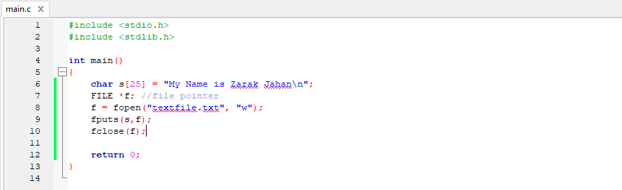

**OUTPUT:**

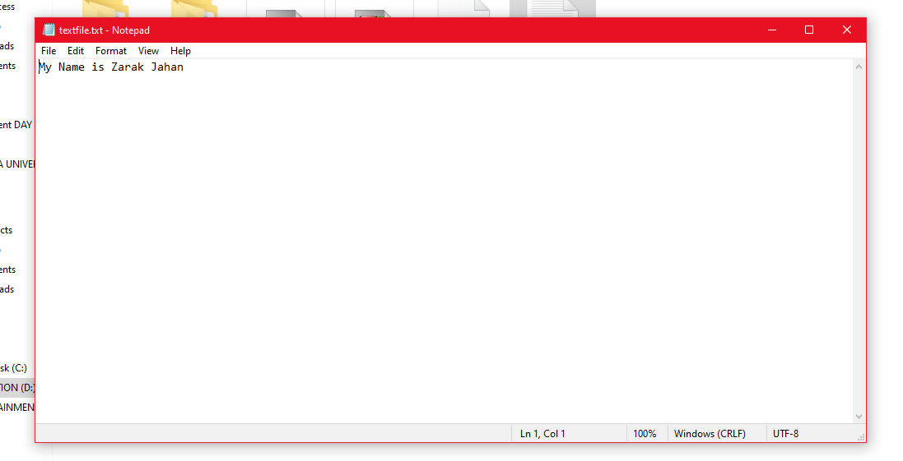

**Q2: What are predefined libraries of c and c++? List five main pre-defined libraries and explain them.**

**SOLUTION:**

A library in C is a collection of header files, exposed for use by other programs. The library therefore consists of an interface expressed in a .h file (named the "header") and an implementation expressed in a .c file.

1. stdio.h − It is a standard i/o header file in which Input/output functions are declared
2. conio.h − This is a console input/output header file.
3. string.h − All string related functions are in this header file.
4. stdlib.h − This file contains common functions which are used in the C programs.
5. math.h − All functions related to mathematics are in this header file.
6. Is there any function or program for graphical designing or interface in c and c++?

**Q3: Is there any function or program for graphical designing or interface in c and c++?**

The graphics.h header file provides access to a simple graphics library that makes it possible to draw lines, rectangles, ovals, arcs, polygons, images, and strings on a graphical window. Few functions included in graphics header file are:

* Circle(); :- This function Draw a circle at (x, y) of the given radius
* getmaxx(); :- This function return maximum X coordinate on the screen.
* getmaxy(); :- This function return maximum Y coordinate on the screen.
* setcolor(); :- This function sets the current drawing color.
* closegraph(); :-This function shuts down the graphics system.

**Q4: What are the command lines for creating c file and for creating c++ file in Linux and mac os. What are the commands for running them in both os systems?**

To compile:

In Linux:

C= gcc [programName].c -o programName

C++= g++ [programName].cpp -o programName

In Mac:

C= gcc -Wall -o program program.c

C++= clang++ -o program program.cpp

To run:

In Linux:

C= ./programName

C++= ./programName

In Mac:

C= ./program

C++= ./programName

**Q5: Give extension for compiled file for c and c++ files in all three os systems.**

For C= .c

For C++= .cpp